**Notes:**

Remove insulation layer:

<https://www.instructables.com/DIY-Magnetic-Compass/>

Part list:

* DF06M – full bridge rectifier <https://www.digikey.com/product-detail/en/on-semiconductor/DF06M/DF06M-ND/977156>
* Neodymium Cylinder - 20mm x 25mm (grade 42) [https://amfma gnets.co.nz/neodymium-cylinder-20mm-x-25mm.html](https://amfmagnets.co.nz/neodymium-cylinder-20mm-x-25mm.html)
* Pope Clear Vinyl Tubing 25mmx0.900m <https://www.bunnings.co.nz/pope-clear-vinyl-tubing-25mmx0-900m_p0235250>
* 0.25 enamel copper wire <https://www.jaycar.co.nz/0-25mm-enamel-copper-wire-spool/p/WW4012>
* Super Capacitor <https://www.digikey.com/en/products/detail/elna-america/DK-6R3D105T/970179>
* resistor, led(s)

Simulation demonstrating Faraday’s law:

<https://phet.colorado.edu/sims/html/faradays-law/latest/faradays-law_en.html>

Experiment:

1. 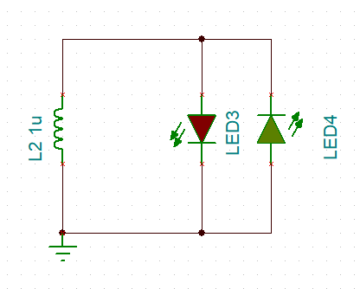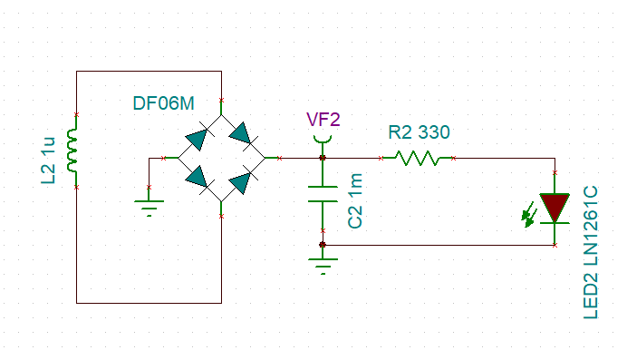Making a compass
2. Faraday’s law – 2 leds parallel
3. AC - DC -> constant voltage (practical)

Notes – **What**, **Why,** **How** (keep it simple)

1. Introduction – **Why** did I choose this project
2. Content Overview – **What** will they learn
3. Content – **How** they will learn this concept
4. Conclusion – Summary of content i.e. similar to content overview
5. Questions – Understanding

Main learning outcome = The fundamentals

Faraday's law of induction

Faraday's law of induction is a basic law of electromagnetism predicting how a magnetic field will interact with an electric circuit to produce an electromotive force —also known as electromagnetic induction.

* A changing magnetic field will induce an EMF in a loop of wire

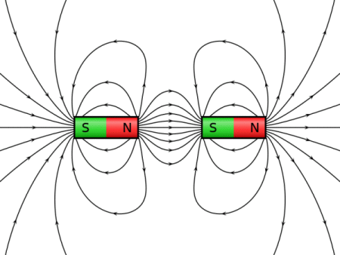Difference between Magnetism and Electromagnetism: <https://www.google.com/search?q=is+magnetis+and+electro+magnetism+the+same&rlz=1C1CHBF_enNZ877NZ877&oq=is+magnetis+and+electro+magnetism+the+same&aqs=chrome..69i57j33l2.14000j0j4&sourceid=chrome&ie=UTF-8>

* Magnetism
  + Has magnetic fields
* Electromagnetism (one of the four fundamental forces)
  + 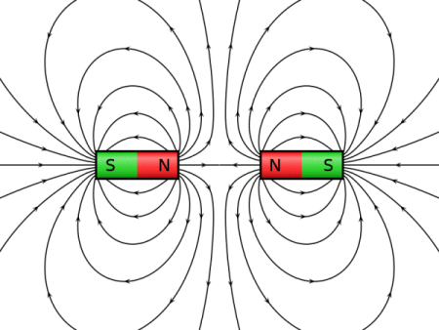Has magnetic and electric fields

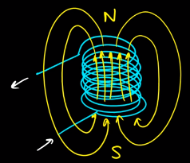<https://physics.stackexchange.com/questions/184186/why-opposite-poles-of-magnet-attract-each-other-why-dont-they-repel/184258>

Electromagnet = a magnetic field is created when electric current is induced in a wire.

An **electric field** is essentially a force **field** that's created around an electrically charged particle.

<https://www.diffen.com/difference/Electric_Field_vs_Magnetic_Field#:~:text=The%20area%20around%20a%20magnet,produced%20by%20moving%20electric%20charges.&text=A%20moving%20charge%20always%20has,are%20associated%20with%20each%20other>.

A **magnetic field** (No charge created) is one that's created around a permanent **magnetic** substance or a moving electrically charged object.

**electric field** ex = has a magnetic field around the coil, when current exists

**magnetic field** ex = has a magnetic field around a magnet, no current flowing

Magnetism (Exp. I) = No coils just magnets – demonstrates magnetic fields

Electromagnetism (Exp. II) = Moving a magnet through a coil, thus creates current to be induced in the coil

* moving charge always has both a **magnetic** and an **electric field**

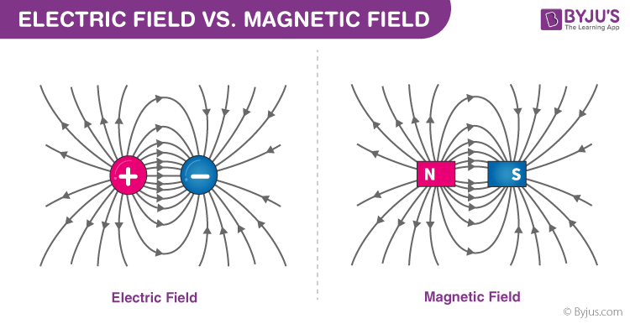

<https://byjus.com/physics/difference-between-electric-field-and-magnetic-field/>

We know that Electric current through a coil has magnetic fields. (Current through a coil)

Michael Faraday – Wanted to know if the reverse was possible - electromagnetic induction

* Can a steady magnetic field create an electric current? **No**
* Can a changing magnetic field through a coil induce a current? **Yes**

Extra:

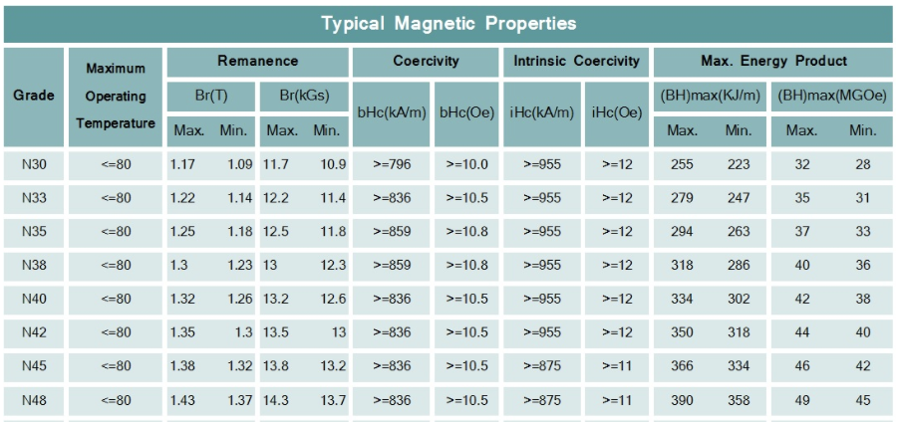

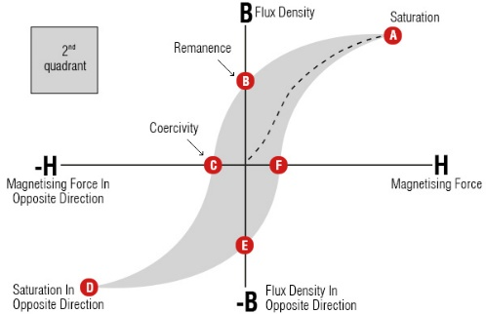Remanence = the magnetic flux that remains in a magnetic circuit after an applied magnetomotive force has been removed.

Concavity = gap

Magnetomotive force = The driving force that causes a magnetic field (number of coil turns times current)

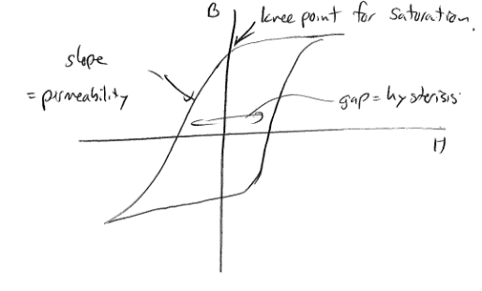B-H curve

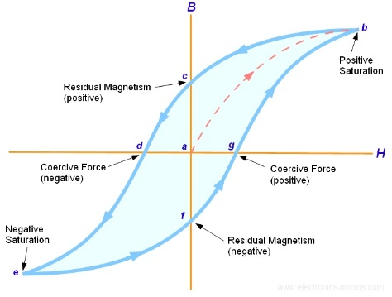

<http://ffden-2.phys.uaf.edu/webproj/212_spring_2017/Max_Erickson/PrettyPhysicsProject/page2.html>

<https://www.google.com.pk/search?q=lenz%27s+law&biw=983&bih=615&source=lnms&tbm=isch&sa=X&sqi=2&ved=0ahUKEwilmeWCh8XOAhVClxoKHXufDGoQ_AUIBygC#imgrc=BBmLe9rw_3-r7M>

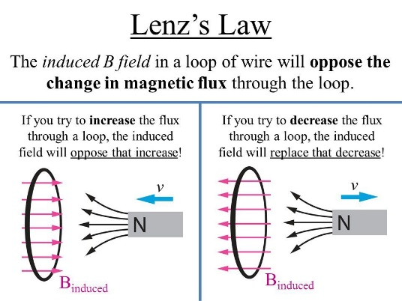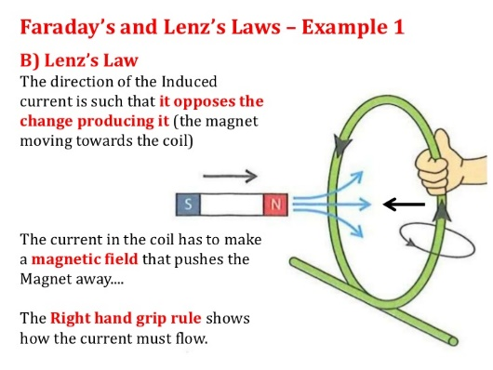

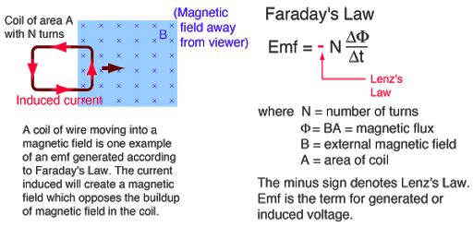

A **galvanometer** is an electromechanical instrument used for detecting and indicating an electric current – Faraday (discovered electric fields)

Current induces magnetic fields

Changing fields induce current

**Introduction**

* Mihi
* What is this project about?
  + ECE is developing some activities suitable for Year 8 to Year 10 School children aimed at encouraging  an  interest  in  **STEM**  (Science,  Technology,  Engineering  and  Mathematics)  and  engineering  in  particular.
* Why are we making this project?
  + To excite and encourage children who have not already developed such an interest  to give engineering a chance.
* Expectations and Requirements (Do I add specifications?)
* Looking for electrical engineering equivalent  of the “Mouse Trap Car”.
* Last approximately 90 min.
* One tutor present per group
* Cost limit of $500
* No voltages above 20 V (DC or RMS AC)
* Easy to change components
* Schematic showing electronics
* CAD drawing’s for manufacturing
* User guide for the tutors about the activity
* **What** will they learn?
  + Magnetism
  + Electromagnetism - Faraday's and Lenz’s law of induction (Magnetism and electric charge)
* **Why** should they learn this?
  + Can Electric current be created withought using a battery? – If we could, it would Reduce the amount of chemicals
* **How** will they understand this concept?
  + Making a compass - Experiment I
* Magnetism
* To check which side is north and south of the big magnet – What they’ll do
  + Faraday's experiment modified - Experiment II
  + Practical use – The shaking flashlight - Experiment III
    - * This is how Electromagnetism can be used in the real world

Emf (the voltage generated) = is the rate of change of flux around a coil

* A tutor’s user guide for the activity should be drafted and should explain:
  + Set of items required.
  + The aim.
  + Steps involved (illustrations where appropriate).
  + Successful or unsuccessful outcomes – What they hope to achieve.